Install OpenVAS (GVM)

What you DO on Linux:- sudo apt update && sudo apt upgrade -y sudo apt install gvm -y sudo gvm-setup sudo gvm-start

Section: Installation of OpenVAS

I installed the OpenVAS (Greenbone Vulnerability Manager) package on my Linux machine using the default package manager.
The installation included the OpenVAS scanner, the Greenbone Security Assistant (web interface), and the PostgreSQL database.
After installation, I ran the gvm-setup command to initialize the system and downloaded the vulnerability feeds.
Finally, I started the OpenVAS services using gvm-start.
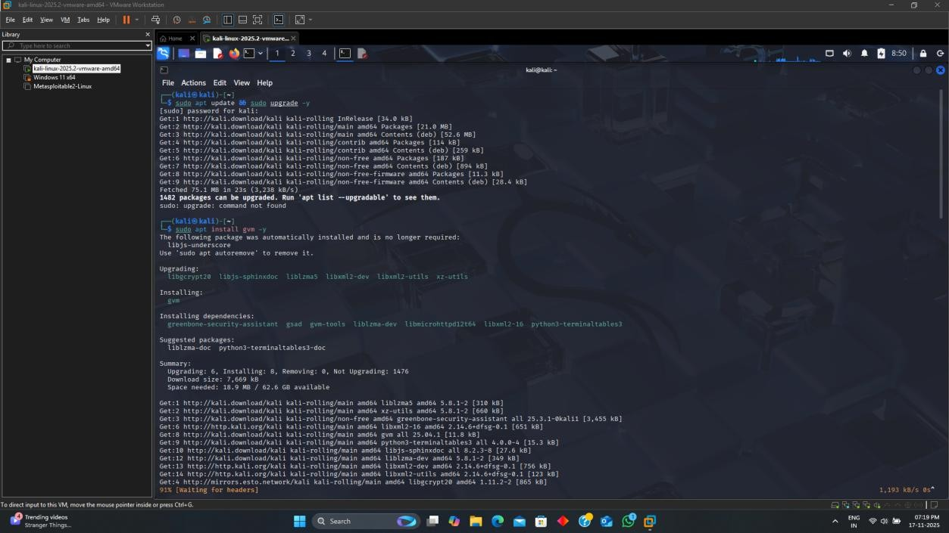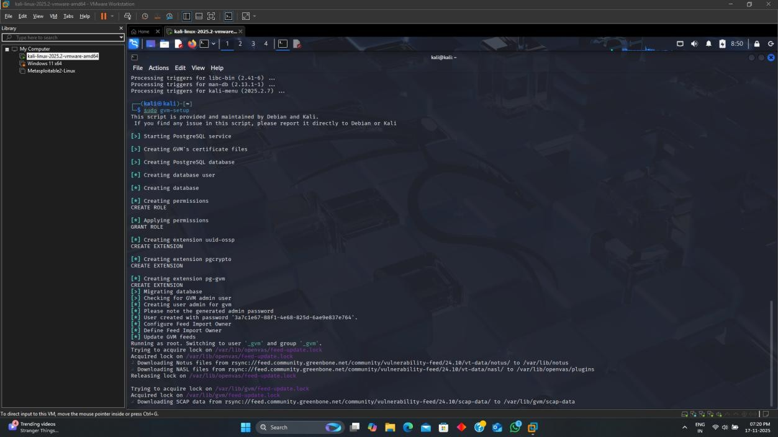
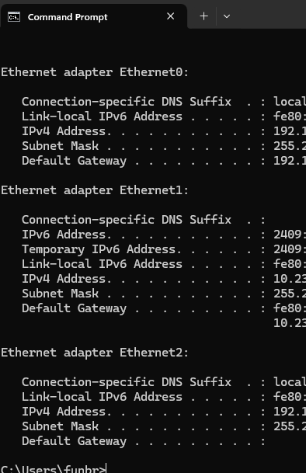

I identified my system’s local IP address using the command ip a.
The detected IPv4 address was 192.168.X.X, and this address was used as the target machine for the vulnerability scan.
This ensures the scan focuses only on my own system as required.

Configuring the Scan Target
I created a new target in GVM and named it “My Linux System.”
I added my system’s IP address to ensure the scanner only analyzes my device.
This step defines the scope of the vulnerability scan
I created a new scan task using the “Full and Fast” scan configuration, which provides a thorough scan with reliable performance.
I assigned my previously created target to this task.
This task defines how the scan will run and what level of analysis will be performed.
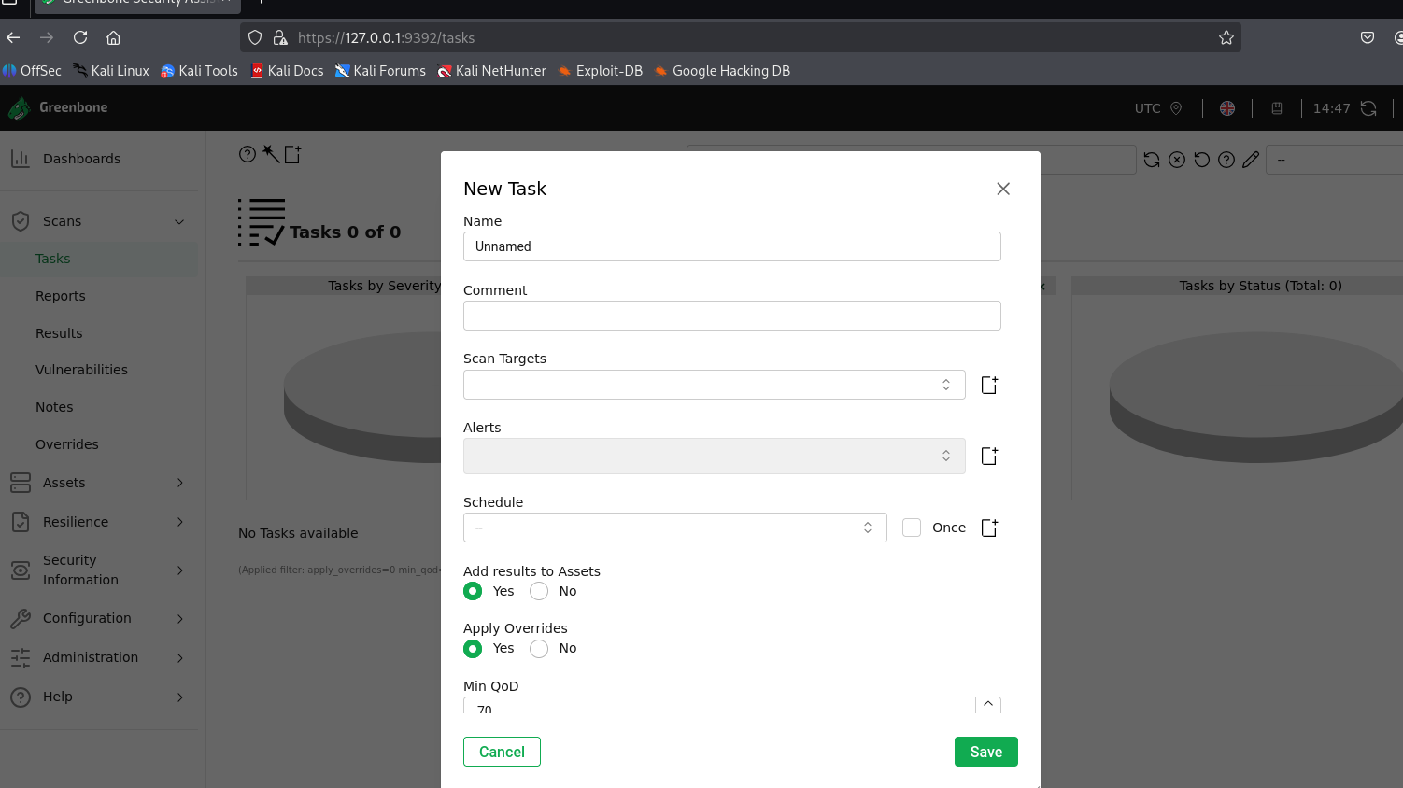
initiated the vulnerability scan by starting the task “Full System Scan.”
The scan took approximately 10–45 minutes depending on system resources.
During this scan, OpenVAS analyzed the system for known vulnerabilities, misconfigurations, outdated packages, and insecure services.

The scan detected vulnerabilities on my Linux system.
The issues were categorized into Critical, High, Medium, Low, and Informational.
Each vulnerability was reviewed individually, and remediation steps were noted.

